i

ELCOT

[Email address]

projects

By M.MALATHI

COST CATEGORY AND COST CENTRE

|  |  |  |
| --- | --- | --- |
| PARTICULARS | DEBIT | CREDIT |
| SBI BANK | 800000 |  |
| CASH IN HAND | 100000 |  |
| FURNITURE | 200000 |  |
| BUILDING ADVANCE | 150000 |  |
| COMPUTER | 500000 |  |
| STOCK IN HAND | 150000 |  |
| SOFTWARE DEPOSIT | 100000 |  |
| CAPITAL |  | 1000000 |
| O/S BUIDING RENT |  | 20000 |
| O/S SALARY |  | 80000 |
| LOAN FROM BANK |  | 700000 |
| HINDUSTHAN COMPUTER LIMITED( SUNDRY CREDITOR) | DURATION 25 DAYS | 150000 |
| PAVAI BOOKS NOTES AND PRINTERS (SUNDRY CREDITOR ) | DURATION 25 DAYS | 50000 |

COST CATEGORY AND COST CENTERS

COST CATEGORY –INCOME AND EXPENDITURE

COST CENTER –APPLICATION FEE , COURSE FEE

SUB COST CENTERS : APPLICATION FEE

* COMPUTER APPLICATION
* ENTRANCE APPLICATION

COURSE FEE

* TALLY
* DCA
* DTP
* DIT
* ALSO THERE IS SO MANY SUB COST CENTERS IN THIS

|  |  |
| --- | --- |
| APPLICATION FEE | COMPUTER APPLICARTION |
|  | ENTRANCE APPLICATION |
| COURSE FEE | DCA |
|  | COURSE FEE (DCA) |
|  | COURSE METERIAL (DCA) |
|  | DCA FORE NOON |
|  | DCA AFTER NOON |
|  | DCA WEEK END |
|  | TALLY |
|  | COURSE FEE (TALLY) |
|  | COURSE METERIAL(TALLY) |
|  | TALLY FORE NOON |
|  | TALLY AFTER NOON |
|  | TALLY WEEKEND |
|  | DTP |
|  | COURSE FEE (DTP) |
|  | COURSE METERIAL(DTP) |
|  | DTP FORE NOON |
|  | DTP AFTER NOON |
|  | DTP WEEKEND |
|  | DIT |
|  | COURSE FEE (DIT) |
|  | COURSE METERIAL (DIT) |
|  | DIT FORE NOON |
|  | DIT AFTER NOON |
|  | DIT WEEKEND |

TRANSACTION

1) CASH RECEIVED FOR TALLY F/N 22000

2) COURSE FEE RECEIVED FOR TALLY A/N 30000 AND COMPUTER APPLICATION 5000 BY CHEQUE

3) COURSE FEE RECEIVED FOR TALLY DAY TIME 120000 AND DCA 75000 DTP 90000 AND DIT 110000

SUMMER OFFER DISCOUNT 2% FOR EACH COURSE

4) ENTRANCE APPLICATION RECEIVED 10000

5) TALLY COURSE AFTER NOON REFUND 5000

6) COURSE METERIAL FOR TALLY ,DIT ,DTP 50 COPIES @ 5000,3000, 1000 EACH

7) AMOUNT PAID TO HINDUSTHAN SETTELEMENT 75000 AS A PART SETTELMENT

8) COURSE FEE FOR DIT FORENOON 15000 REFUND AND DCA AFTER NOON 5000

9) DEPRECIATION OF FURNITURE AND FITTENGS AT 10 %

10) THE REFUND AMOUNT OF DIT FORENOON AND DCA AFTER NOON FULLY RECEIVED

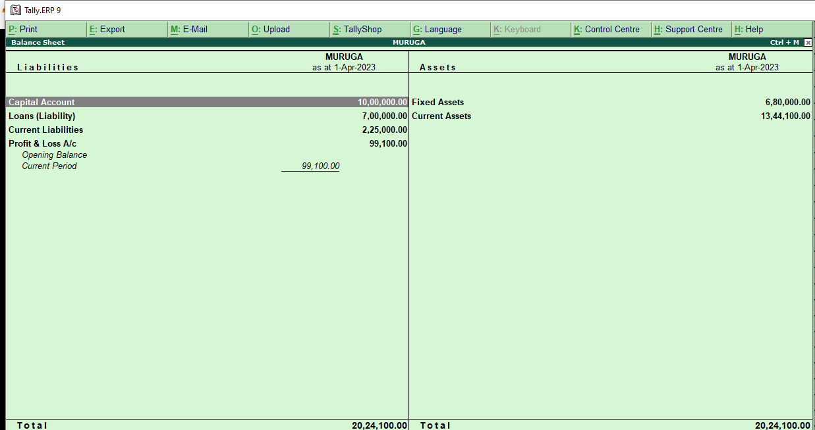

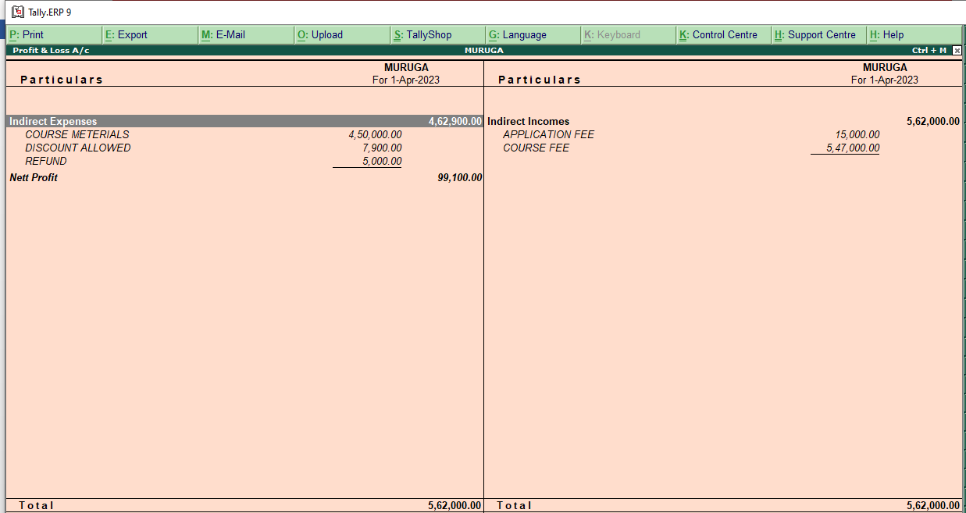

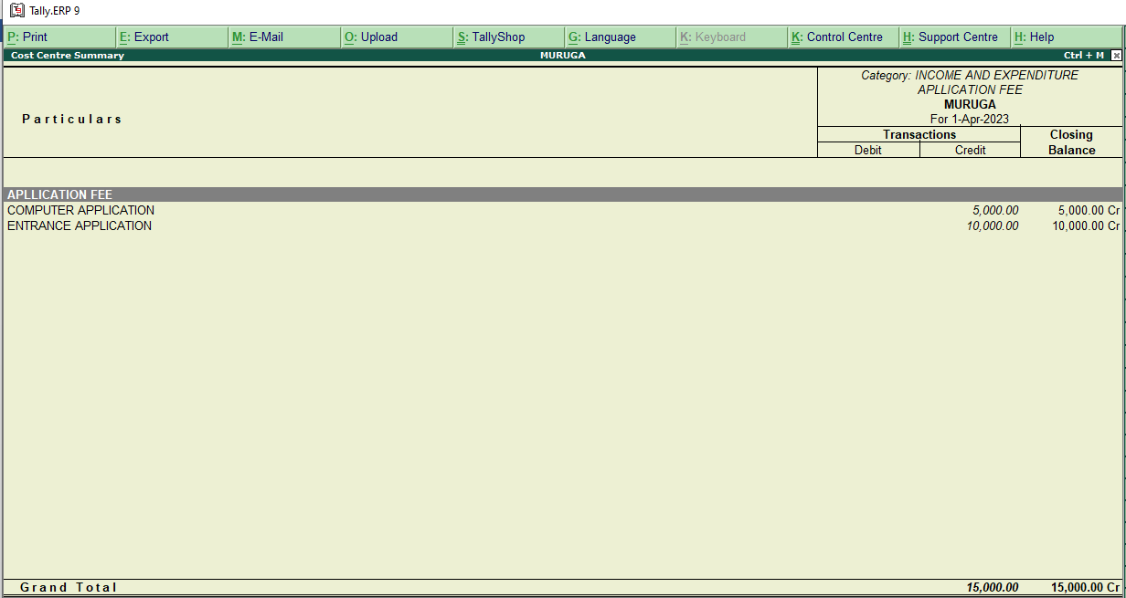

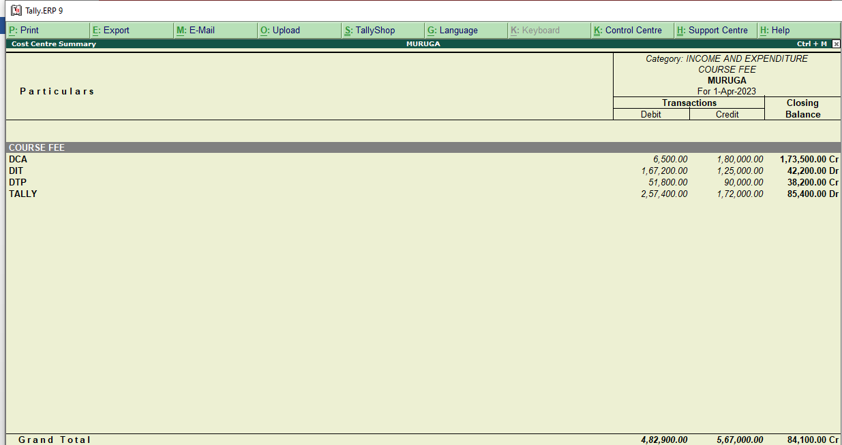

PROJECT COMPLETED

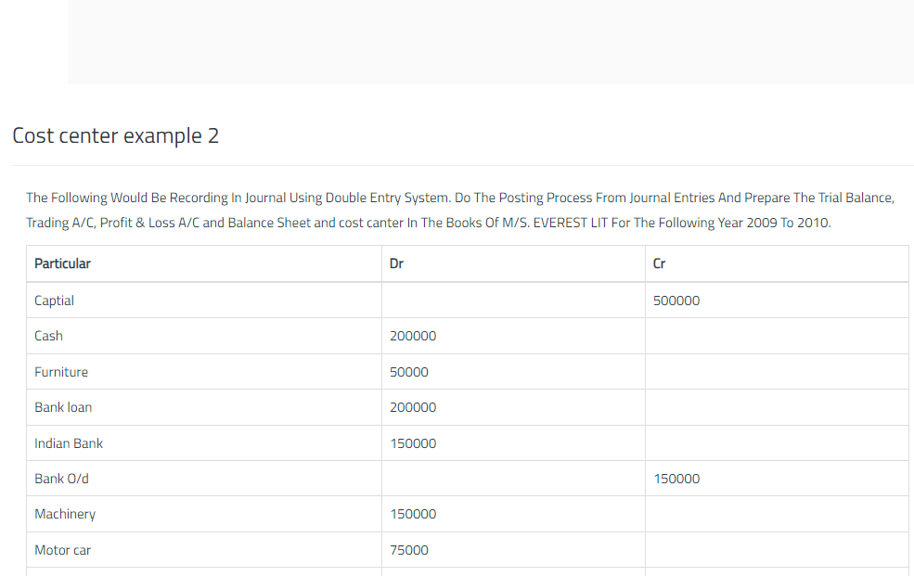

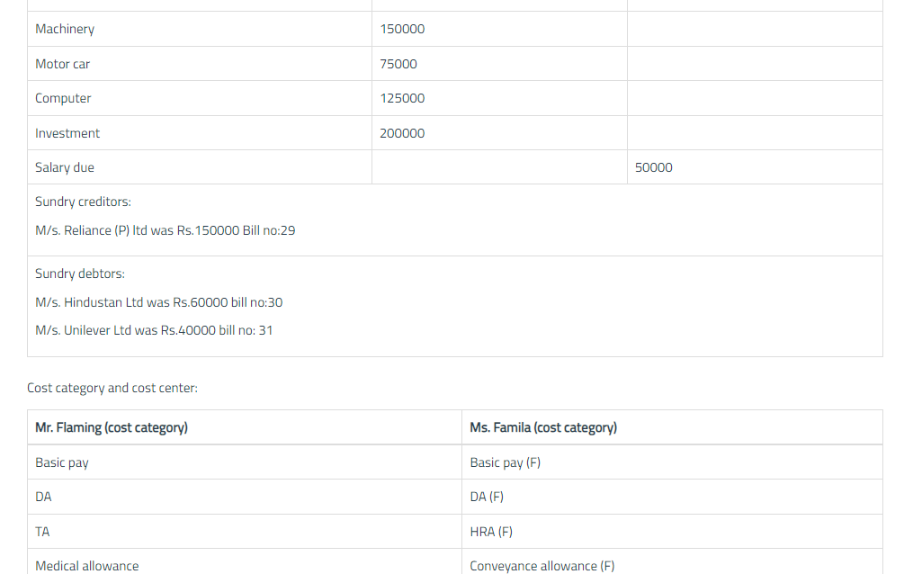

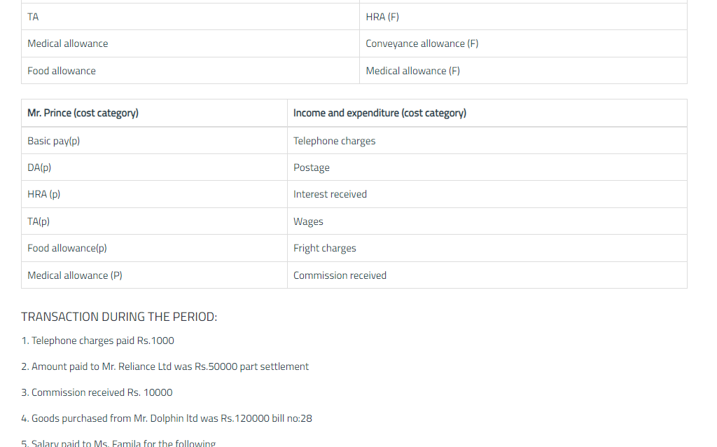

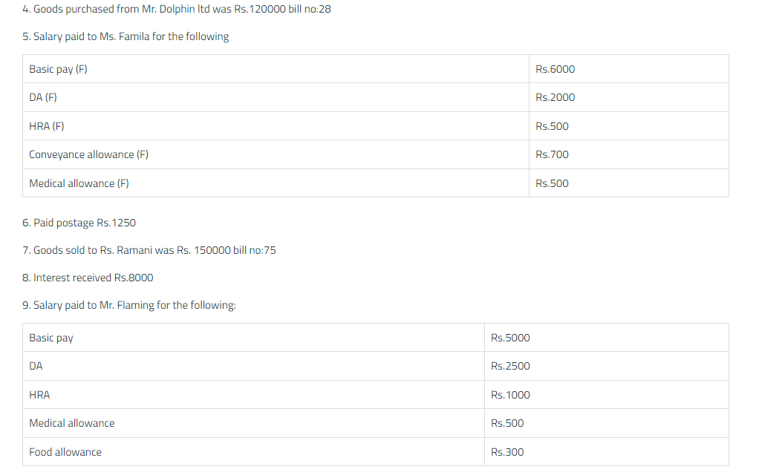

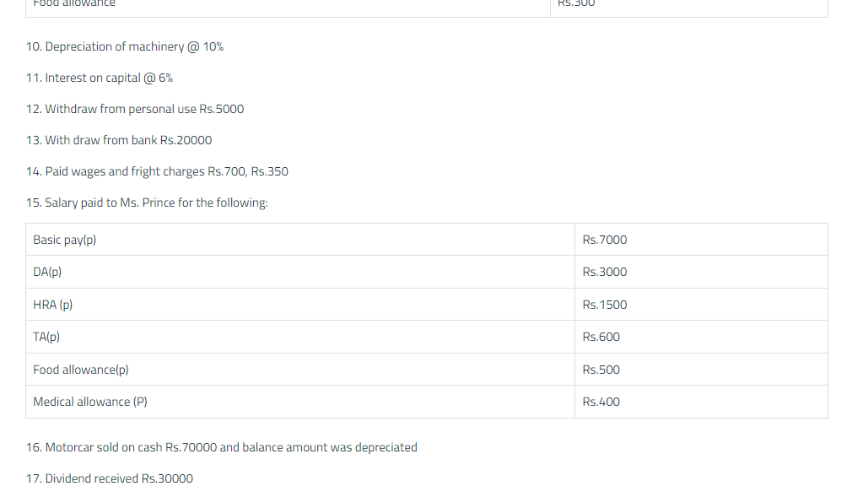

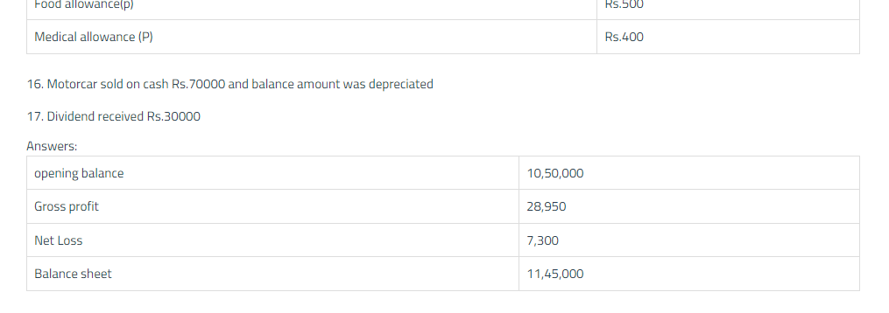

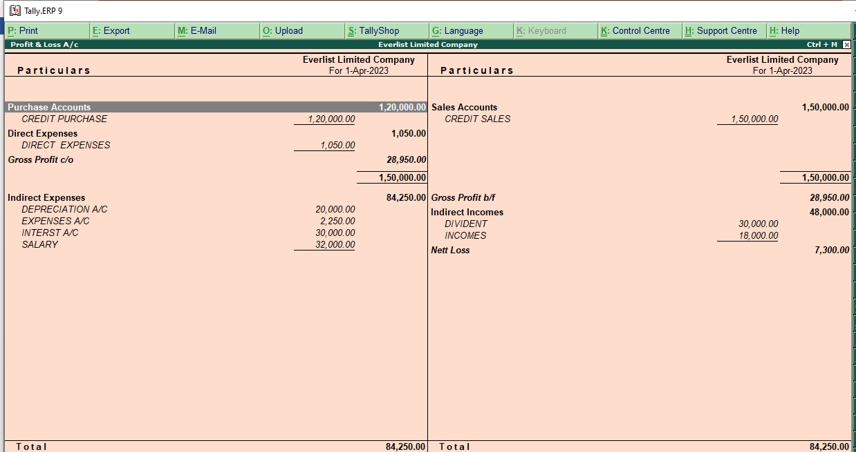

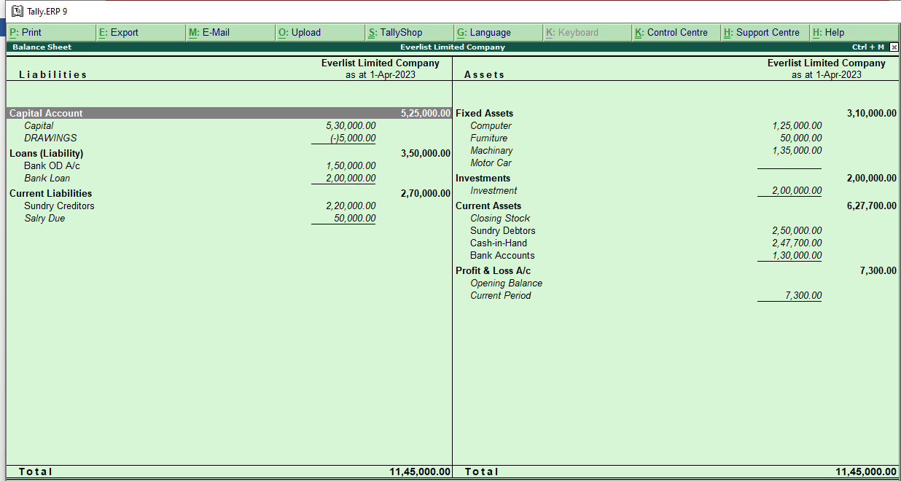

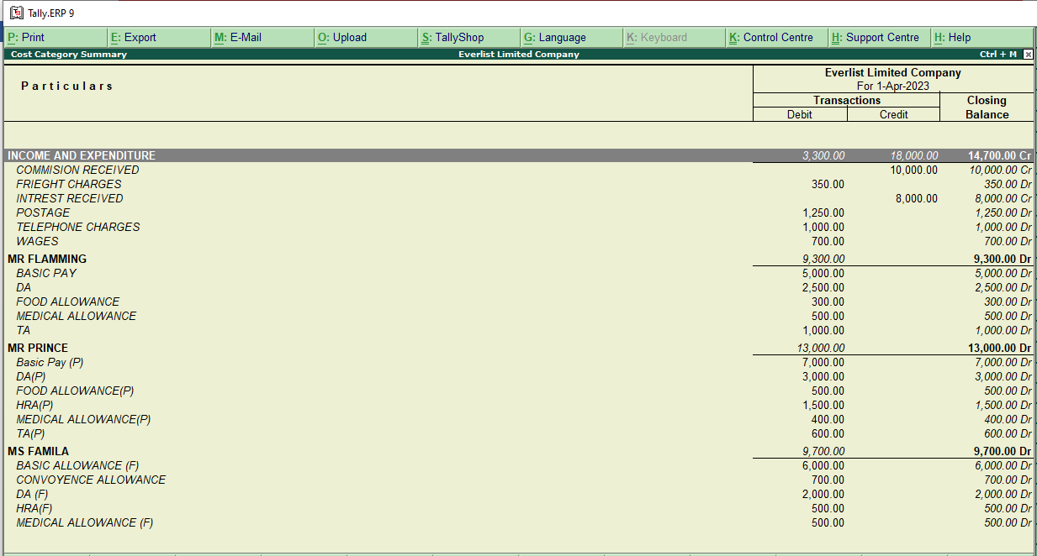

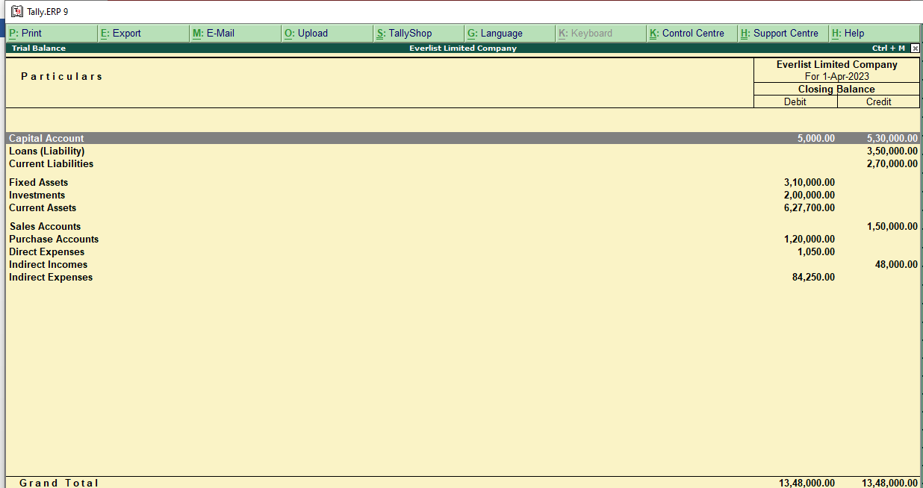

PROJECT SUCCESSFULLY COMPLITATED

Project no 3

LAXMI GROUP OF COMPANIES

|  |  |  |
| --- | --- | --- |
| PARTICULARS | DEBIT | CREDIT |
| CAPITAL |  | 1000000 |
| SUNDRY DEBTOR | 400000 |  |
| SUNDRY CREDITOR |  | 100000 |
| COMPUTER | 500000 |  |
| BANK LOAN |  | 200000 |
| CASH IN HAND | 400000 |  |
| MACHINARY | 400000 |  |
| DEBENTURE |  | 400000 |
|  |  |  |

INCOME AND EXPENDITURE

|  |  |
| --- | --- |
| PARTICULARS | MISELLIONES |
| OFFICE EXPENSES | DISCOUNT RECEIVED |
| TRAVELLING EXPENSES | DISCOUNT ALLOWED |
| FACTORY CURRENT CHARGES | INTERST PAID |
| DRAWINGS A/C | INTREST RECEIVED |
| WAGES | RENT RECEIVED |
| SALARY | COMMISSION RECEIVED |

SALARY FOR MALATHI SALARY FOR KUMAR

|  |  |
| --- | --- |
| BASIC PAY | BASIC PAY |
| DA | DA |
| TA | TA |
| MEDICAL ALLOWANCE | FOOD ALLOWANCE |
| TRAVELLING ALLOWANCE | MEDICAL ALLOWANCE |

ASSETS AND LIABILITY

|  |  |
| --- | --- |
| FURNITURE | BILLS PAYABLE |
| CASH IN BANK | LOAN |
| BILL RECEIVABLE | BANK INTREST |
| STOCK IN HAND | RENT |
| RENT PREPAID |  |

1. GOODS PURCHASED FROM MOHAN ON CREDIT 23000
2. SELLING THE GOODS TO THE VIMALA ON CREDIT 100000
3. SELLING THE GOODS ON CASH 20000
4. SELLING THE FURNITUURE ON CASH 23000
5. MONEY RECEIVED FROM VIMALA WITH @ 5% DISCOUNT ALLOWED
6. BANK INTEREST PAID 200
7. BANK LOAN RETURNED 10000
8. SALARY TO THE SMALL LEVEL OFFICE WORKERS 2000
9. 